THE CRUCIBLE WALL AT HIGHBURY HALL, BIRMINGHAM
by Dr. Jim Andrew
Introduction

On the eastern boundary of the Highbury Hall estate and close to the estate manager’s house is a massive twenty feet high retaining wall, above the drive from the estate to Queensbridge Road. It appears to be built of very rough quality “earthenware pots”.

The inspection
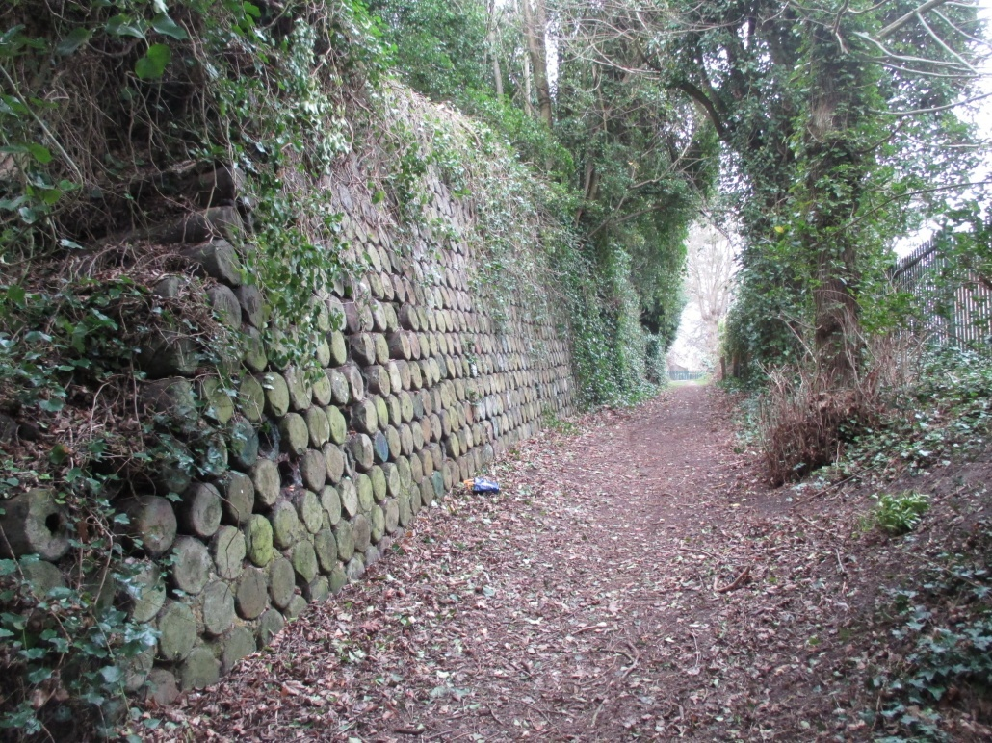
I was asked, by Phillada Ballard, a trustee of the Hall, to look at the “pots” and where they might have originated. Particularly whether they came from the Chamberlain’s business activity or contacts. In addition to the very high wall, and the earth banked up against it, on the estate side is a lower wall but in both cases there could be further layers of “pot” below the visible ones
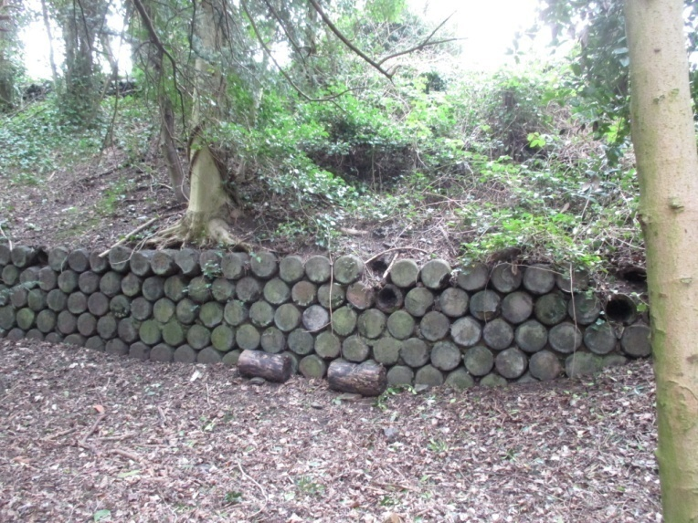
Also on the estate side, the inner edge of the high wall was exposed showing that the “pots” are open ended and some four feet long. The open ends of the “pots” appear that the tops have been broken off.
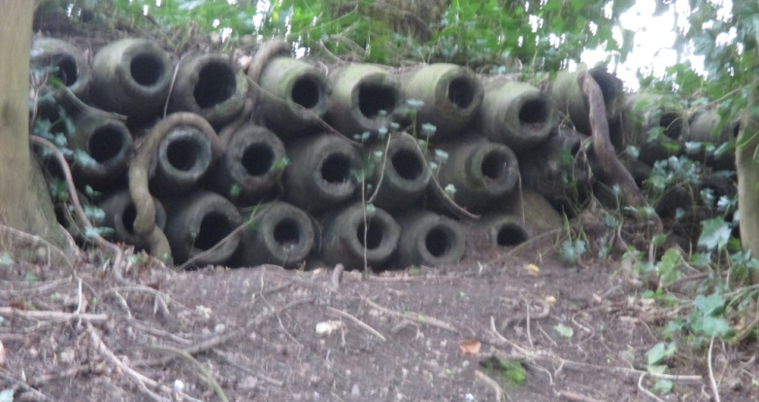
Phillada had found the wall marked on maps of around 1900 but had no idea of any other record of it so it could be of an earlier date. Phillada is continuing research in the Highbury and Chamberlain archives for any details about the bank and walls. There are substantial trees and other vegetation growing in the massive earth bank which the wall retains. The pots were measured and a broken sample taken for examination
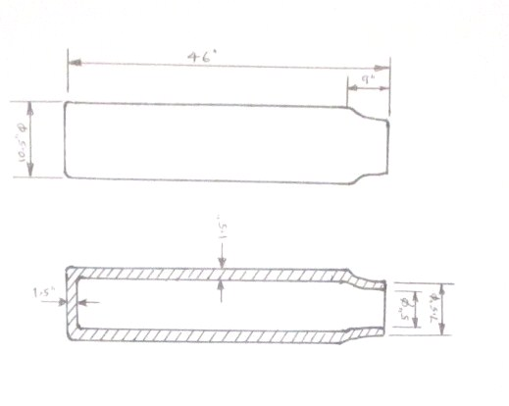

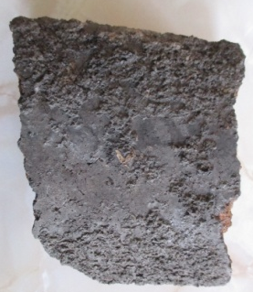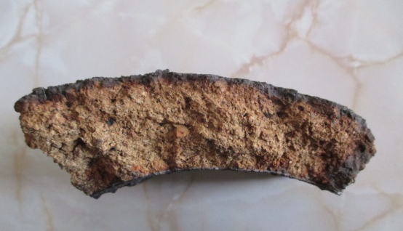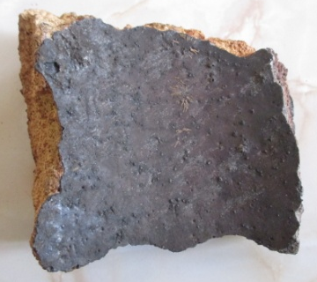
the outside broken side of a “pot” the inside

The pot sides are some 1.5 inches thick, as shown here, of a composition found in course fire bricks using fire clay and small stones fired to make a high temperature resistant product. The outside and inside have a dark coating which may have been a special coating, the effect of heat or of the heated product within.

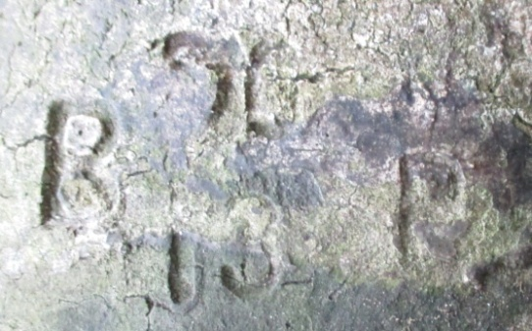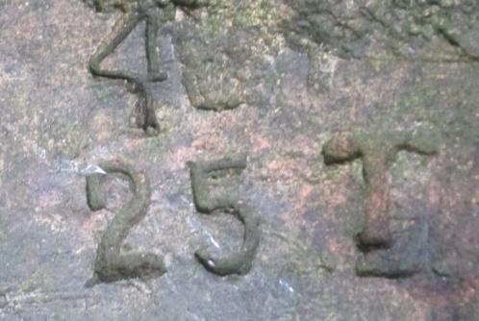

The pots have incised markings which indicate a mass production of the items but no further clue as to their source or use. There are several sets of other incised markings on the “pots” but none reveal any more information. It is however clear to the author of this report that these “pots” are a type of crucible, probably for heat treatment in metal manufacture.

A few calculations

Weighing the sample piece of the crucible and using the dimensions of the crucibles the weight of each crucible calculates to about 150 lbs. The tall retaining wall is some 90 feet long by 20 feet high meaning that it contains about 1840 crucibles while the smaller back wall contains 280 giving a total number of crucibles in sight of 2,120. The total weight of visible crucibles is around 140 tons.

Some thoughts about this feature

The amount of earth deposited against the main retaining wall would have required a considerable weight in that retailing wall. It is assumed that the crucibles are left over from some process where they had a limited number of re-uses before being abandoned. Most have quite bad damage to the mouth which was presumably sealed during each use. It could be that reuse of the crucibles solved two problems, a source of convenient heavy building material and the need to dispose of a waste product. Thus, this is a convenient piece of recycling which seems to have created a very stable structure.

The crucibles

I have not found any illustrations of crucibles of this form but crucibles were available in a variety of forms in the nineteenth century. Knight’s Practical Dictionary of Mechanics c1878, Volume 1 p 653 shows a “steel pot” among the crucibles, which has some resemblance to those in the wall, and a machine for shaping them. Such a machine could also have formed the crucibles in the Highbury wall.

“d” is a steel pot Moulding crucibles

Use of the Crucibles

Two heat treatment processes spring to mind for this type of crucible. For over 150 years wrought iron was turned into crucible steel by pieces of wrought iron being packed in powered carbon in a crucible and kept at a high temperature in a furnace while the carbon diffused through the wrought iron, raising its carbon content, and converting it into steel. Even better steel was produced if the crucible steel was the melted so the impurities, slag, from the wrought iron floated to the top and could be run off.
The other possibility is that the crucibles were used in case hardening some of the smaller steel products of Birmingham firms such as those connected with the Chamberlains. In this case the steel products were packed in mixtures of carbon and other chemicals which, under heat, would defuse into the surface of the products giving a much harder wearing surface while the rest of the product gave the strength needed for the item’s use. This “case-hardening” allowed a brittle hardwearing coating to be applied to a strong component which could, if necessary then be ground to the accurate dimensions required.

Conclusions

I suspect that the crucibles were selected to give a really stable retaining wall for the great
bank on the edge of the estate where it might well both hide the adjacent property, another
large house and estate, or reduce the noise of social gatherings next door. It would certainly
be effective as a sound baffle with the twenty feet vertical high wall and suitable vegetation
planted along its top. The sloping of the earth bank as it approached the sound or vision
barrier was sloped up to give an effect not unlike the “ha-ha” found in many stately home
estates which kept animals in the park from entering the formal gardens. This arrangement
would then disguised the drop beyond to give an open vista.

I have no doubt that the Chamberlains, with their many contacts, could have sources such
useful re-cycled crucibles from within Midland industry.

Jim Andrew
April 2017

Brief CV of Jim Andrew
I am a mechanical engineer who worked in industry and local authority pollution control before joining the senior staff of Birmingham Museums in 1974. I have been based at the Museum of Science & Industry in Newhall Street and then at the new Science Museum, Thinktank, in Eastside. I retired from full time employment in 2003 but was retained as a self-employed advise at the museum for another ten years. I have also held part time and, later voluntary, posts with Birmingham University, local museums and industrial heritage sites.

